QIAamp PowerFecal DNA Protocol

Goal: Obtain highly pure DNA from samples for use in downstream applications

Introduction:

The QIAamp PowerFecal DNA Kit provides a method to obtain a high yield of exceedingly pure DNA from a variety of samples (stool, environmental, rumen, etc). The QIAamp PowerFecal DNA Kit utilizes Inhibitor Removal Technology® (IRT) which removes substances such as heme compounds, bile salts, and Polymerase Chain Reaction (PCR) inhibitors that would lead to false quantification of nucleic acids. The resulting high-quality DNA can be used in downstream applications such as qPCR, Sanger sequencing, and next-generation sequencing (NGS).

Basic Procedure:

Sample will be aliquoted in bead beating tubes containing garnet beads. During bead beating, cells will be lysed due to the impact of beads and chemical breakage of cell membranes. Inhibitory substances will be removed by IRT via a series of provided solutions. DNA will be bound, washed, and eluted from a silica membrane in a spin column leaving highly pure DNA for downstream applications such as PCR analysis, qPCR, and NGS.

QIAamp PowerFecal DNA Kit Procedure

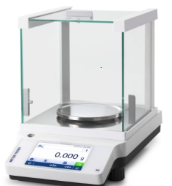

* Weigh sample and add to Dry Bead Tube

Aliquot sample

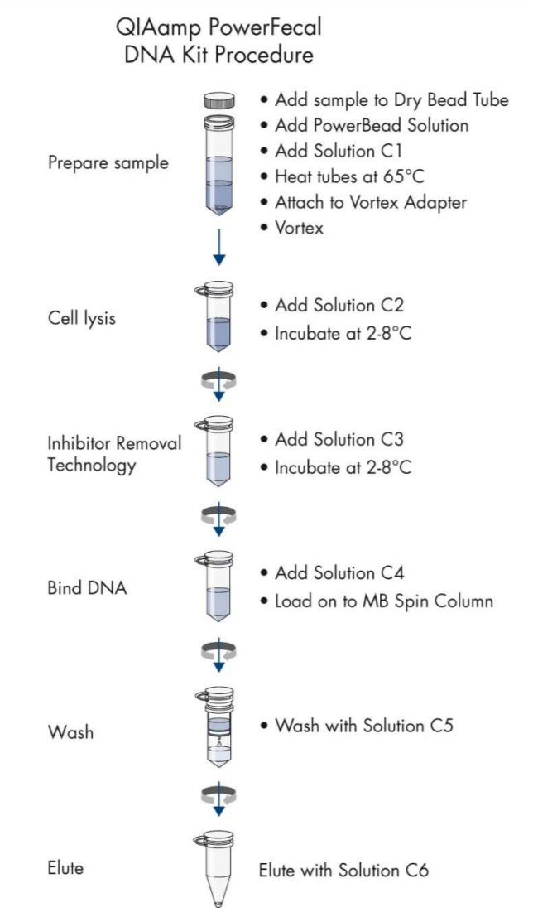

* Add PowerBead Solution
* Add Solution C1

Prepare sample



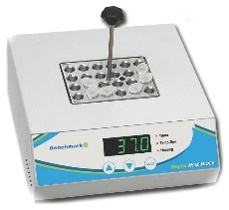

Heat Tubes

* Heat at 65°C



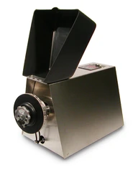

Repeat5 times

* Vortex with Bead Beater
* Rest in between pulses

Cell Lysis



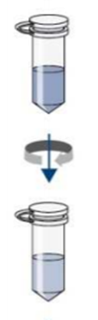

* Mix sample and Solution C2

Inhibitor Removal Technology



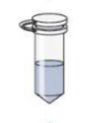

* Mix sample and Solution C3

Inhibitor Removal Technology



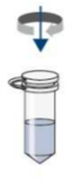

* Mix sample and Solution C4

Bind DNA



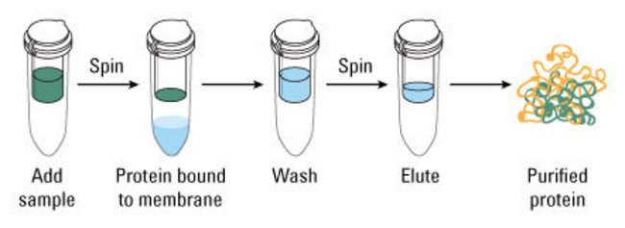

* Load sample to MB Spin Column

Load Sample



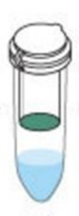

Repeat 3 times

* DNA bound to membrane
* Contaminants flow through

Centrifuge



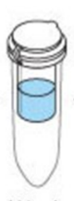

* Wash with Solution C5

Wash







* Elute with Solution C6

Elute

Centrifuge eluent





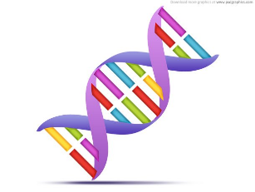

* Ready for Downstream Applications

Highly Pure DNA

Protocol:

This protocol is adapted from the Qiagen’s PowerFecal protocol with the following changes:

Important points before starting

* Perform all centrifugation steps at room temperature (15 – 25°C).
* If Solution C1 has precipitated, heat at 60°C until precipitate dissolves.
* Shake well to mix Solution C4 before use.
* Heat Solution C6 to 70°C for use in step 16 (Final elution).
* When centrifuging, make sure centrifuge is operating in x g and not in rpm.

Procedure:

1. Depending on the consistency of the sample, use a small flat object, suction dropper, or cut pipette tips to weigh and add up to 100 mg (may vary) of sample to Bead Tube. Record amount in notes.

**Note:** This amount may vary slightly depending on the lipid, polysaccharide, and protein composition of the sample. Smaller amounts of sample may be better if the concentration of these are high in the sample.

1. Add 750 µl of PowerBead Solution to Bead Tube.

**Note:** The next step is homogenization and lysis. The garnet beads and PowerBead Solution helps to separate particles.

1. Add 60 µl of Solution C1 to Bead Tube and vortex briefly. If Solution C1 has precipitated, heat at 60°C until precipitate dissolves.

**Note:** Solution C1 is a mixture of SDS and other disruption agents required for cell lysis. SDS aids in cell lysis and is an anionic detergent capable of breaking down fatty acids and lipids which are associated in cell membranes. White precipitate in the bottle is an indication that the solution is cold and needs to be warmed for proper use. Heating will not harm SDS or disruption agents and Solution C1 can still be used while warm. Vortexing helps to mix contents in the bead tube and disperses the sample.

1. Heat tubes at 65°C for 10 min.

**Note:** Fecal samples especially contain numerous polysaccharides, lipids, salts, and cells. By heating the sample, the reaction rate between the lysis buffer and these components is increased which helps cell lysis.

During this time prepare separate aliquots of C2, C3, and C4 solutions in clean 2 ml tubes. Prepare one aliquot of each solution for each sample.

* + 1. C2 tubes with 250 µl of Solution C2
    2. C3 tubes with 200 µl of Solution C3
    3. C4 tubes with 1200µl of Solution C4

1. Secure bead tubes horizontally in the Mini-Beadbeater-16 and beat (3450rpm fixed) for 1 minute with 5 minutes rest in between pulses. Beat and rest a total of 5 times each (Total of 5 minutes beating, 25 minutes resting).

**Note:** Vortexing is key for homogenization and cell lysis. Chemical agents added in the above steps in addition to mechanical shaking drives the lyses of cells. Using the vortex adaptor to create collisions of beads with microbial cells in the presence of these disruption agents will lead to higher DNA yields and maximum homogenization.

1. Centrifuge bead tubes at 13,000 x g for 1 min.
2. Transfer up to 450 µl of supernatant to the corresponding prepared C2 tubes and vortex briefly.

**Note:** The exact volume of the supernatant will vary depending on the amount and absorbency of starting material. C2 has IRT which precipitates non-DNA organic and inorganic material that would prevent reliable quantification of nucleic acids. This is important to removing inhibitors that would reduce DNA purity and hinder downstream DNA applications.

1. Centrifuge tubes at 13,000 x g for 1 min.
2. Avoiding the pellet, transfer up to 600 µl of supernatant to the prepared C3 tubes and vortex briefly.

**Note:** The pellet at this step is a composite of non-DNA organic and inorganic material including polysaccharides, cell debris, and proteins. Therefore, avoid transferring any of the pellet at this step to ensure higher DNA yields. C3 also contains IRT to remove non-DNA organic and inorganic material. Again, the presence of polysaccharides, cell debris, and proteins will impact DNA purity and the success of downstream DNA applications.

1. Centrifuge tubes at 13,000 x g for 1 min.
2. Avoiding the pellet, transfer no more than 750 µl of supernatant to prepared C4 tubes and vortex for a full 5 seconds.

**Note:** The pellet contains non-DNA organic and inorganic material that will hinder downstream applications. For the best yield and quality, avoid transferring any of the pellet. Solution C4 is a high-concentration salt solution that allows DNA to bind to silica. The adjustment of the salt concentration specifically allows DNA – not non-DNA organic and inorganic material – to bind to the MB Spin Column.

1. Load 650 µl of sample to either an Econospin© silica filter or a Qiagen® MB Spin Column and centrifuge at 13,000 x g for 1 min. Discard the flow-through and repeat until all sample has been processed (three passes).

**Note:** Maintain 1 filter type for all extractions of the project. Because of the high salt solution, DNA is selectively bound to the MB Spin Column and remaining contaminants pass through the filter.

1. Add 500 µl of Solution C5 to filter and centrifuge at 13,000 x g for 1 min.

**Note:** Solution C5 is an ethanol-based solution used to wash the DNA bound to the MB Spin Column. The solution allows DNA to stay bound to the MB Spin Column but removes remaining salt and other contaminants.

1. Discard the flow-through and centrifuge again at 13,000 x g for 1 min (dry spin).

**Note:** The flow-through is a mix of non-DNA organic and inorganic waste as a result of C5 wash solution. The dry spin removes remaining Solution C5 and is vital to prevent interference of ethanol with downstream DNA applications.

1. Carefully place the MB Spin Column in a clean 1.5 ml collection tube.

**Note:** This will typically be the final storage tube, therefore, label accordingly. Avoid splashing any Solution C5 onto the MB Spin Column.

1. Add 52 µl of pre-warmed 70°C Solution C6 to the center of the white filter membrane.

**Note:** This elution step with Solution C6 maximizes DNA yield and using 52µl generates more concentrated DNA. Ensure that Solution C6 is placed in the center of the filter membrane to moisten the entire membrane.

1. Let Solution C6 sit in the membrane at room temperature for 5 minutes

**Note:** Allowing Solution C6 to incubate allows for full hydration of the silica filter to help release DNA during centrifugation.

1. Centrifuge at 13,000 x g for 1 min and then pipet eluent back to the center of the white filter membrane.

**Note:** By doing this, DNA is thoroughly released from the MB Spin Column. DNA previously bound to the MB Spin Column in the presence of high salt will be released by Solution C6 (10mM Tris) due to the lack of salt in solution.

1. Centrifuge at 13,000 x g for 1 min (second pass) and then discard the MB Spin Column. The DNA in the tube is now ready for downstream applications.

**Note:** We recommend storing DNA frozen (-20°C to -80°C) as Solution C6 (10mM tris-HCL) does not contain EDTA.

Common Results:

Some of the most common downstream applications after obtaining DNA in this protocol is a qubit assay and TapeStation. Both are used to check the quantity and quality of DNA which is important for even further downstream applications.

A Qubit assay is typically performed as the next step after extraction. The frequently used Qubit dsDNA high sensitivity assay is a way to specifically quantify DNA via fluorescent dyes. The fluorescent dyes bind to dsDNA in this case and upon binding it fluoresces. The concentration of DNA can be found easily as it is the direct result of the intensity of fluorescence as shown in the graph.

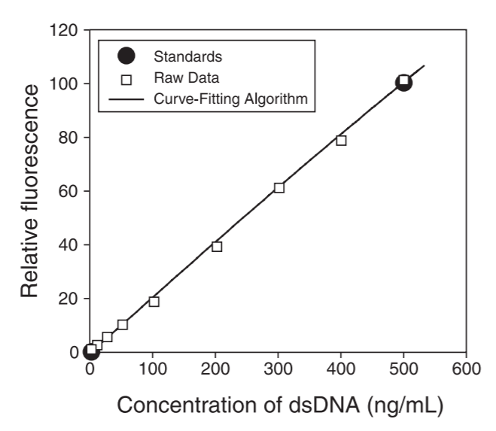

ThermoFisher User Guide: Qubit dsDNA HS Assay Kits

TapeStation is another powerful quality control tool commonly used after library preparation in the workflow for NGS. It utilizes automated electrophoresis which gives the size of DNA. The concentration, yield, and integrity of the sample can also be assessed in between a certain base pair range. The figure below shows electrophoresis results and the fluorescence intensity vs. base pair size.

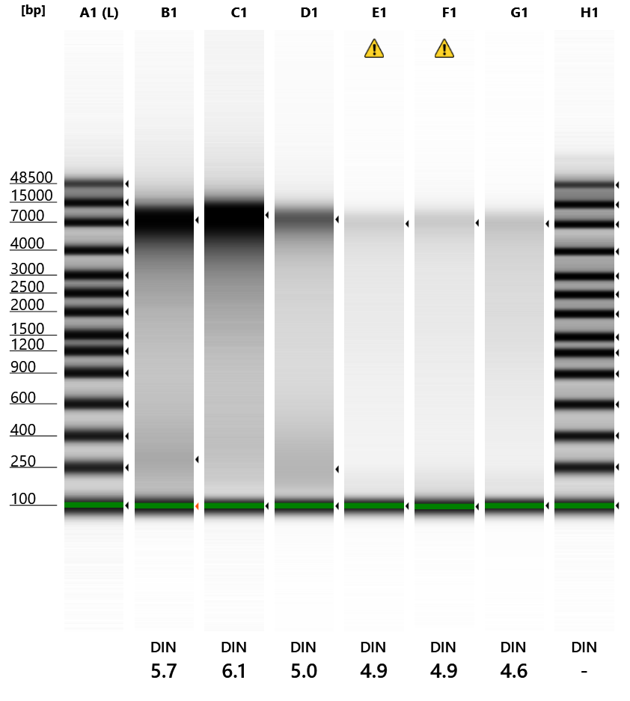

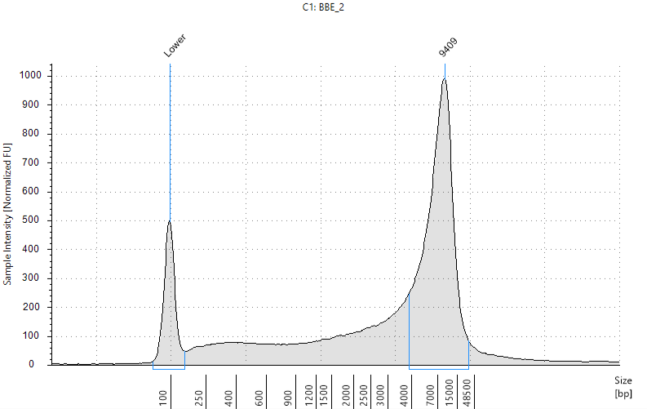

Agilent TapeStation: DNA ScreenTape & Graph

Helpful Links

QIAamp® PowerFecal® DNA Kit Handbook: <file:///C:/Users/valen/Downloads/HB-2252-001_1104555_HB_QA_PowerFecal_DNA_0817_WW%20(2).pdf>

ThermoFisher Scientific Qubit Assays: <https://www.thermofisher.com/us/en/home/industrial/spectroscopy-elemental-isotope-analysis/molecular-spectroscopy/fluorometers/qubit/qubit-assays.html?gclid=Cj0KCQjwka_1BRCPARIsAMlUmEqzt1MsVTOQ7_ORPDQoqHPkANis5xjer0VGSlDJZrAHrGbERHMX82waAgflEALw_wcB&ef_id=Cj0KCQjwka_1BRCPARIsAMlUmEqzt1MsVTOQ7_ORPDQoqHPkANis5xjer0VGSlDJZrAHrGbERHMX82waAgflEALw_wcB:G:s&s_kwcid=AL!3652!3!393988167276!e!!g!!qubit%20assay?cid=bid_pca_aqb_r01_co_cp1359_pjt0000_bid00000_0se_gaw_bt_pur_con>

Agilent TapeStation: <https://www.agilent.com/en/product/automated-electrophoresis/tapestation-systems/tapestation-dna-screentape-reagents/dna-screentape-analysis-228260>

ThermoFisher Scientific Extraction Protocol (slightly modified): <https://www.youtube.com/watch?v=7muQSoATQV8>

Images taken from

Agilent TapeStation DNA ScreenTape & Reagents<https://www.agilent.com/en/product/automated-electrophoresis/tapestation-systems/tapestation-dna-screentape-reagents/dna-screentape-analysis-228260>

Homogenizers. BioSpec Mini-Beadbeater. <https://homogenizers.net/products/mini-beadbeater?variant=43387814608&utm_medium=cpc&utm_source=google&utm_campaign=Google%20Shopping&gclid=Cj0KCQjwka_1BRCPARIsAMlUmEq_qAWXzCvDBpRh3EQ9hEi74jd_5Hsbk6jciSHWbdmMpUrF1Cwwo_saArVhEALw_wcB>

Mettler Toledo. ME-TE Brochure. <https://www.hogentogler.com/images/Mettler_ME-TE_brochure.pdf>

QIAamp PowerFecal DNA Kit Handbook 2017. <file:///C:/Users/valen/Downloads/HB-2252-001_1104555_HB_QA_PowerFecal_DNA_0817_WW%20(2).pdf>

ThermoFisher User GuideL Qubit dsDNA HS Assay Kits <https://www.thermofisher.com/document-connect/document-connect.html?url=https%3A%2F%2Fassets.thermofisher.com%2FTFS-Assets%2FLSG%2Fmanuals%2FQubit_dsDNA_HS_Assay_UG.pdf&title=VXNlciBHdWlkZTogUXViaXQgZHNETkEgSFMgQXNzYXkgS2l0cw==>

ThermoFisher Scientific Protocol Summary for Strong Cation and Anion Exchange Spin Columns. <https://www.thermofisher.com/document-connect/document-connect.html?url=https%3A%2F%2Fassets.thermofisher.com%2FTFS-Assets%2FLSG%2Fmanuals%2FQubit_dsDNA_HS_Assay_UG.pdf&title=VXNlciBHdWlkZTogUXViaXQgZHNETkEgSFMgQXNzYXkgS2l0cw==>

Universal Medical. Digital Dry Bath. <https://www.universalmedicalinc.com/digital-dry-bath-one-block.html>

365 PSD. DNA strands, medical icon. <https://365psd.com/psd/dna-strands-medical-icon-psd-53140>